**Centrality Examples:**

In this document we’re going to look at how the different centrality methods rank different nodes. Some of the different methods we’ve come across so far in the course are: **In-Degree** (the number of in edges to that node), **Closeness** (the measure of how close a node is to all other nodes), B**etweenness** (finds the nodes that are most common in the shortest path between other nodes), **PageRank** (this is the probability of landing on a node after taking a random walk with k steps), **Authority Hubs** (this is similar to PageRank, but uses two variables).

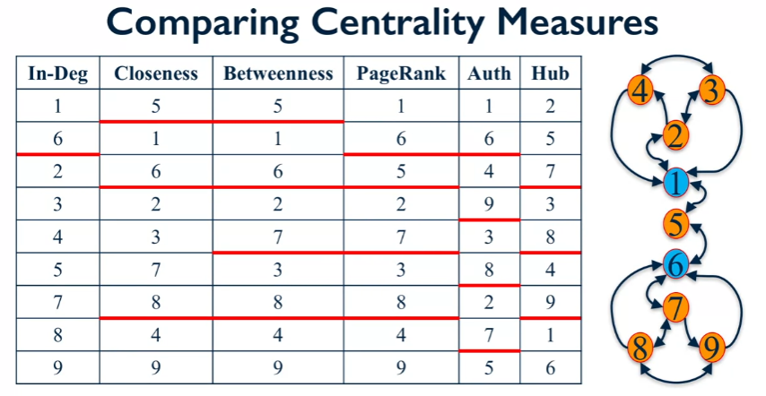

The above table shows from top to bottom the highest scores of different centrality measurements, with red lines indicating a different score.

Betweenness’s results are quite similar to the Closeness results however the betweenness results is able to prob the structure of the network a little better. For example, the closeness centrality ranks nodes 2,3 and 7,8 the same, however, if you wanted to go from node 5 to 4 you wouldn’t have to go through 3.

We can see that there is quite a large variation in the different score of the different methods, but commonly the nodes 1 and 6 are high.

